**Transportation Sales Tax Fund**

|  |  |
| --- | --- |
| **Project Name:**  **1st & Bridge Street Round-A-Bout** | **Department:**  **Public Works** |
| **Type of Project:**  **Rehabilitation / Replacement** | **Contact**:  **Chuck Soules** |
| **Total Project Cost:**  **$3,440,267** | |

**Description:**

The existing intersection at the intersection of Bridge Street, Hilltop Street, and East 1st Street poses significant challenges to both motorists and pedestrians. The intersection's odd angles make it difficult for drivers to navigate, and the lack of clear pedestrian crossings creates confusion for walkers. As a result, motorists are often looking for quicker ways through the intersection, leading to speeding and failure to come to a complete stop.

The situation also affects residents of the housing authority who do not have access to cars and rely on walking to local shopping areas. Without a clear and safe pedestrian route, these residents may be at increased risk of accidents and injuries. To address these challenges, the City is proposing the construction of a roundabout to replace the existing intersection.

GBA was hired to design this project for a total cost of $440,267. In 2025 the City spent about $140,000.

**Justification:**

The City of Smithville applied for a grant from MARC in 2022 to fund the proposed roundabout project, and the City was awarded this grant. The project aims to address the challenges of the existing intersection at Bridge Street by improving safety, promoting sustainable transportation options, and optimizing vehicular flow. The roundabout will provide a clearer and safer route for pedestrians and bicyclists, while enhancing traffic flow for all users of the intersection.

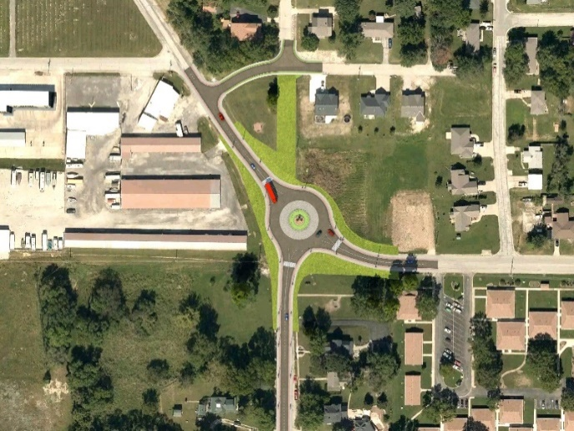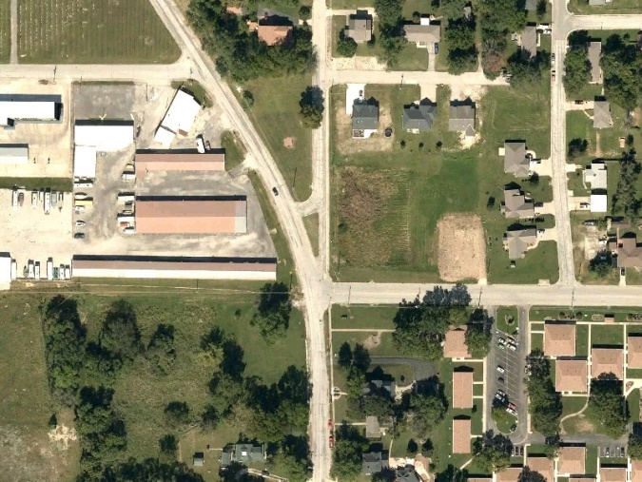

**Planned Expenditures**

|  |  |  |  |
| --- | --- | --- | --- |
|  | **FY2026** | **FY2027** | **Total** |
| **Engineering** | **$300,000** |  | **$340,267** |
| **Construction** | **-** | **$3,000,000** | **$3,000,000** |
| **Total** | **$300,000** | **$3,000,000** | **$3,340,267** |

**Funding Sources**

|  |  |  |  |
| --- | --- | --- | --- |
|  | **FY2026** | **FY2027** | **Total** |
| **Transportation Sales Tax** | **$150,000** | **$2,400,000** | **$2,400,000** |
| **Capital Improvement Sales Tax** | **$150,000** | **$600,000** | **$600,000** |
| **MARC Grant**  **(Reimbursement)** | **-** | **($900,000)** | **($900,000)** |
| **Total Net Cost** | **$300,000** | **$2,100,000** | **$2,100,000** |